# Exact Online – Dropbox File Transfer Project

## Prerequisites

Here are the prerequisites to run and execute the project:

* Visual Studio 2017
* .Net Framework 4.5.2
* Exact Online account
* At least one existing **Document** in Exact Online
  + NOTE: The transferred files will be added as **Attachment** to the existing Document, please create one Document in Exact Online, if there is no document available.
* A registered App in Exact Online with the following information:
  + Redirect URI the same as application execution url
  + Generated Client Id
  + Generated Client Secret

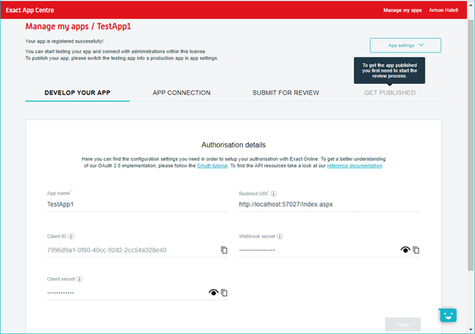

* Dropbox account
* A Dropbox registered App providing following information (as next figure):
  + App Key
  + App Secret
  + Generated Secret Token

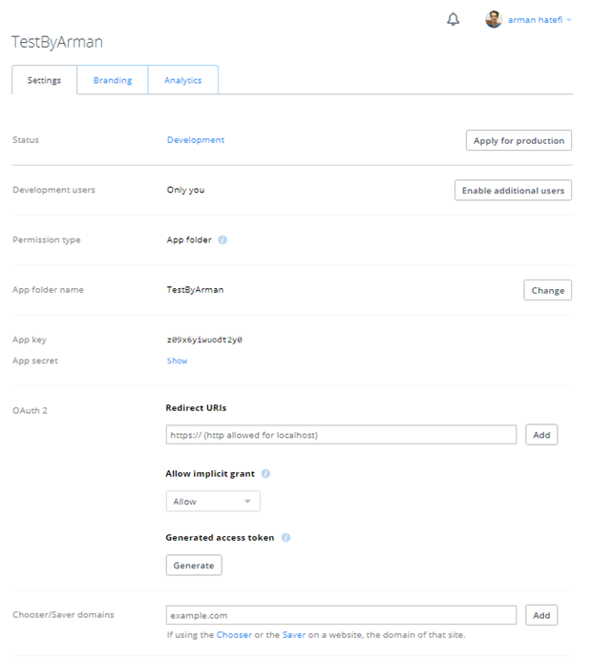

## Program Execution

1. Open the solution in Visual Studio
2. Build and Run the project
3. In the first screen (next figure) enter the information taken from the app registration n both Exact Online and Dropbox

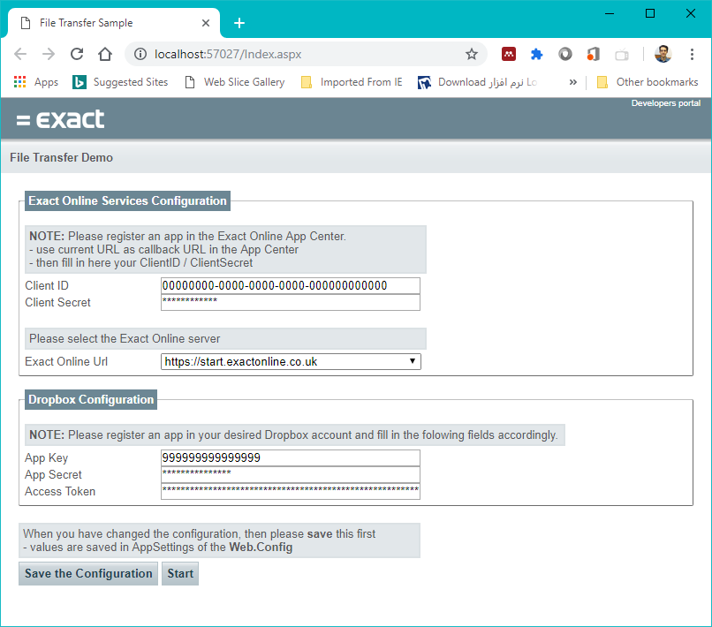

The URI to be used while registering the application in Exact Online.

**Client ID** and **Client Secret** from the application registration in Exact Online.

**App Key, App Secret, Access Token** generated while registering the Application in Dropbox

1. Click “Save the Configuration”
2. Click “Start”
3. Now the screen will be navigated to “Document List” page (next figure)
4. In this screen, the list of available Documents from Exact Online will be listed
5. Next to each Document record, you will find the “**Add Attachment From Dropbox**” link.

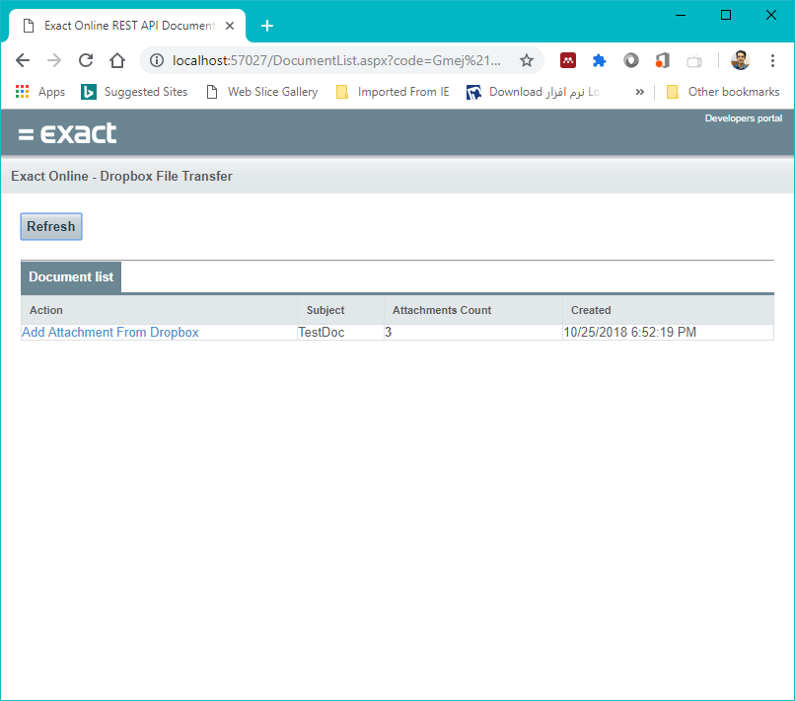

The link to navigate to the File Transfer page.

1. Click on the link to navigate to “Document Attachments” page (next figure)

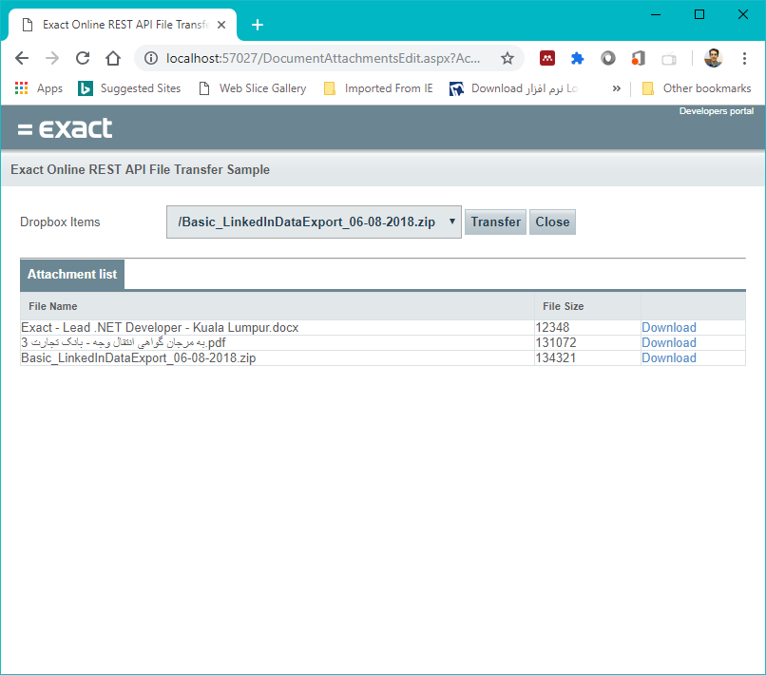

The list of available files in the Dropbox space.

The list of current Document attachments.

1. In this page, you may find the available files in your Dropbox account as listed in the “**Dropbox Item**” drop down list.
2. Select the desired file from the drop down list and click on “**Transfer**” button.
3. After successful transfer, you will find the updated number of attachments in the “Document List” page.

